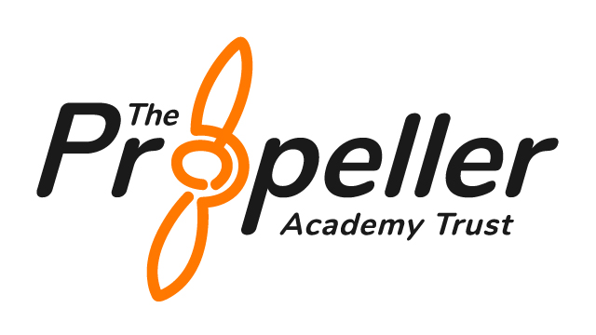
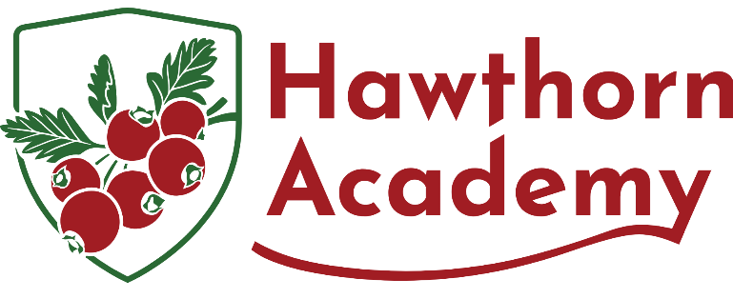

Behaviour and Relationships Policy
Trauma-Informed

Statutory Policy | Yes
Frequency of Review | See DfE guidance
Author | Headteacher
Approved by | Local Governing Board
Date Approved
Reviewed | September 2026
Date of Next Review | September 2027

- Vision, Aims and Purpose
Hawthorn Academy, a trauma-informed SEMH (Social, Emotional and Mental Health) school, we are committed to creating a safe, nurturing, and aspirational environment where every pupil is seen, heard, and supported. We recognise the profound impact of early life adversity on learning, relationships, and behaviour—and we respond with empathy, high expectations, and consistent, relational practice.
Our mission is to enable all pupils to thrive: to become confident, resilient, and self-regulated individuals who can lead fulfilling and independent lives. We support pupils in developing emotional literacy, strong relationships, and the skills to navigate life’s challenges with courage and purpose.
Our vision is brought to life through our core values:
- Belonging – Every child is welcomed, known, and valued as an individual.
- Community – We work in partnership with families, professionals, and networks to support holistic development.
- Respect – All relationships are built on dignity, empathy, and mutual trust.
- Aspiration – We believe in each child’s potential and strive for excellence through personalised support.
- Courage – Pupils are empowered to take safe risks, express themselves, and recover from setbacks with strength.

Purpose of this Policy

This policy ensures a whole-school, trauma-informed approach to behaviour that promotes safety, dignity, and personal growth. Our goal is to develop a community where all members understand the function of behaviour and are equipped to respond restoratively, reflectively, and proactively.
This policy aims to:
- Promote consistent, relational responses to behaviour based on developmental need and emotional regulation.
- Maintain the whole-school responsibility for behaviour through positive, visible reinforcement of shared expectations.
- Recognise the individuality of each pupil, responding with personalised support and an inclusive mindset.
- Foster positive relationships rooted in empathy, mutual trust, and the importance of voice and agency.
- Encourage pupils to understand cause and consequence, develop personal responsibility, and celebrate positive choices.
- Ensure that families and professionals work collaboratively to help children grow socially, emotionally, and academically.

To achieve meaningful outcomes, we use the THRIVE framework:
T – Trusting Relationships: Building safe, secure connections with pupils as the foundation for all learning and behaviour support.
H – High Expectations: Maintaining consistent boundaries and a belief in every pupil’s ability to succeed and grow.
R – Regulation and Reflection: Supporting pupils to understand and manage their emotions through co-regulation and reflective practice.
I – Inclusive Practice: Ensuring every child feels valued and included, with support adapted to individual needs and contexts.
V – Voice and Validation: Encouraging pupils to express themselves and recognising their lived experiences with empathy.
E – Empathy and Empowerment: Responding to behaviour with compassion, enabling pupils to develop agency, responsibility, and resilience.

Our practice is aligned with the Department for Education’s guidance on behaviour and safeguarding, and fully reflects Ofsted and Independent School Standards expectations for safe, inclusive, and effective behaviour support in specialist settings.

- Principles of Behaviour Support

Our trauma-informed behaviour policy is based on the following core principles:
- Behaviour is a form of communication. Staff are trained to understand the function behind behaviour and respond appropriately.
- Emotional regulation must be taught explicitly and supported through co-regulation, modelling, and therapeutic strategies.
- Relationships are central to engagement, trust, and safety. Staff invest time in building secure attachments with pupils.
- Positive behavioural change requires empathy, patience, and consistency.
- Interventions should protect dignity, avoid punitive or shame-based practices, and prioritise relational repair.
- Consequences should be educational, reflective, and restorative.
We aim to build intrinsic motivation and pro-social behaviour through trust, mutual respect, and collaborative problem-solving.

- The 'Ready For' Framework

Our behaviour expectations are based on our 'Ready For' framework which sets clear, consistent, and developmentally appropriate behaviour goals across the school:
Ready for Learning: “I am calm, focused, and open to trying.”
- Pupils use self-regulation tools (e.g. movement breaks, fidget tools) to prepare their minds and bodies.
- They bring required materials and maintain readiness through focus and perseverance.
- Asking for help is encouraged and seen as a strength.
Ready for Others: “I show kindness, listen well, and respect people’s space and feelings.”
- Pupils are taught how to respect boundaries and use calm, inclusive language.
- Social interaction is scaffolded with turn-taking, empathy, and perspective-taking strategies.
Ready for Myself: “I notice how I feel, make safe choices, and ask for help when I need it.”
- Pupils are supported to identify emotions, use their regulation tools, and communicate their needs.
- Reflection and self-awareness are developed through dialogue, journaling, and feedback.
This approach is embedded into classroom routines, visual displays, and reinforced through language used across the school.

- Graduated Behaviour Support Pathway

We use a three-tiered trauma-informed response to behaviour, emphasising regulation, restoration, and relationship repair:
- Tier 1 – Low-Level Behaviour (e.g., off-task, refusal, low-level disruption)
- Gentle redirection using visual cues or non-verbal signals.
- Movement breaks, sensory tools, and co-regulation strategies.
- Quiet space access without shame or removal from learning.
- Positive reinforcement including cross-talk praise and ‘catching pupils doing well.’
- Tier 2 – Medium-Level Behaviour (e.g., verbal escalation, repeated boundary testing, emotional dysregulation)
- Restorative conversations within 24 hours.
- Review of IBSP with additional scaffolds as needed.
- Use of therapeutic stories, social scripts, and comic strip conversations.
- Targeted coaching sessions or check-ins with key adults.
- Home-school collaboration to ensure consistency and joint problem solving.
- Tier 3 – High-Level Behaviour (e.g., physical aggression, unsafe actions, serious emotional crises)
- Physical intervention only when there is no alternative
- Immediate safety response followed by guided repair work.
- Temporary withdrawal or time-in with preferred adult for regulation.
- Multi-agency behaviour review and revised support plan.
- Co-produced restorative contract with pupil, staff, and family.

- SEMH Learning and Emotional Development

We proactively teach behaviour and emotional regulation through embedded curriculum activities, therapeutic interventions, and social development opportunities:

  - 1:1 and small group coaching for emotional literacy, problem-solving, and goal setting.
  - Zones of Regulation, Blob Tree, Colour Monster, and other structured emotional literacy tools.
  - Restorative conversations using scripts and scaffolding to guide empathy and responsibility.
  - Circle time and pupil-led community forums to address shared social dilemmas.
  - Visual and sensory strategies tailored to individual regulation needs.
  - PSHE lessons that integrate role play, real-life scenarios, and conflict resolution.
  - Storytelling, drama, and arts-based therapies to explore emotional themes and build resilience.
  - Digital emotional literacy programs supporting online safety and respectful communication.
  - Pupil voice panels contributing to behavioural expectations and values-led recognition.

- Rewards and Recognition

We celebrate positive behaviour through consistent, meaningful, and inclusive systems that promote self-worth and connection:

  - Verbal and Cross-Talk Praise: Spoken to a third party near the pupil to reinforce without direct attention.
  - Daily Affirmations: Class-based or 1:1 routines to promote belonging and purpose.
  - Certificates and Postcards Home: Celebrating growth, effort, kindness, regulation, and resilience.
  - Time with a Preferred Adult: Offered as a reward and relationship-building opportunity.
  - Sensory and Activity-Based Rewards: Gardening, art, music, games, movement.
  - Classwide Incentives: Co-created group rewards encouraging teamwork.
  - Visual Incentives: achievement walls, and reward menus.
  - Termly Celebration Events: Certificates and praise shared in assemblies or newsletters.

- Reflection and Consequences

Consequences are structured as learning opportunities and are used consistently across the school. We aim to help pupils reflect, restore relationships, and make better choices.
  - Restorative Worksheets and Reflection Journals: Guided tools for exploring what happened, feelings involved, and making amends.
  - Reparation Activities: Fixing damage, writing apology notes, or helping to clean up.
  - Time-In or Regulation Time: Calming, low-stimulation environments supported by a trusted adult.
  - Structured Re-Entry: Visual checklists and supported reintegration plans.
  - Coaching and Role Play: Practising expected behaviours.
  - Debrief Forms and Behaviour Scripts: Collaborative plans capturing voice and next steps.
  - Safety and Restorative Contracts: Agreements outlining support needs and expectations.

- Roles and Responsibilities

All stakeholders share responsibility for creating a safe, respectful, and relational learning environment:
  - Pupils: Engage in self-awareness, take responsibility, and use tools offered to regulate.
  - Staff: Model expected behaviours, maintain consistency, and apply strategies with empathy.
  - Families: Communicate openly with school, support consistency, and celebrate progress.
  - Leaders: Oversee training, implementation, and review of behaviour support practices.
  - Governors: Ensure policy aligns with safeguarding and equality duties, and supports best practice for SEMH pupils.

- Physical Intervention and Safety

Physical intervention is only used when absolutely necessary, in accordance with DfE guidance.
  - Used only when there is imminent risk of serious harm.
  - Interventions must be necessary, proportionate, and in line with the TINSA principle.
  - Staff are trained in de-escalation and safe intervention strategies.
  - All incidents are recorded on the same day, and debriefed with staff, pupil, and family.
  - Pupil voice is captured and integrated into safety planning.

- Searching and Confiscation

In line with the DfE 2022 guidance, pupils may be searched by trained staff if necessary to protect safety.
Searches may take place:
  - With consent for general school rules (e.g., mobile phones).
  - Without consent when items may cause harm (e.g., weapons, drugs, stolen items).
- Prohibited items will be safely confiscated, logged, and families informed. Police and safeguarding services may be involved where appropriate.

- Monitoring and Review

Behaviour data is reviewed termly to evaluate patterns, inform interventions, and improve outcomes. We monitor:

  - Behaviour logs and incident reports
  - Pupil voice and staff reflections
  - Impact of strategies and use of interventions
  - Effectiveness of training and consistency of application
Annual review of policy will be conducted with input from families, staff, and governors.
In alignment with the Department for Education’s 2024 guidance, Hawthorn Academy recognises that certain behaviours may be linked to underlying unmet needs, including issues related to school transitions, past exclusions, and attendance difficulties. We take proactive steps to support pupils during key transitions—whether between lessons, settings, or phases of education—by offering structure, relational consistency, and therapeutic support.
We also acknowledge that behaviour challenges may contribute to or stem from school avoidance or persistent absence. Our graduated response integrates attendance support into personalised behaviour planning, with early identification, family engagement, and multi-agency collaboration as standard practice.
Exclusion—both fixed-term and permanent—is always a last resort, considered only when all other supportive strategies have been fully exhausted and there is a significant and ongoing risk to the safety or education of others. In such cases, re-engagement following fixed-term exclusion is carefully planned with the pupil and their family, using restorative practices, safety planning, and reintegration strategies to ensure emotional readiness, inclusion, and learning continuity.

- Legal Framework

This policy aligns with the following statutory and regulatory frameworks:
  - Keeping Children Safe in Education (KCSIE 2024)
  - Behaviour in Schools DfE Guidance (2024)
  - Equality Act 2010
  - Independent School Standards (Ofsted and ISI)
  - Trauma-Informed Practice Principles

