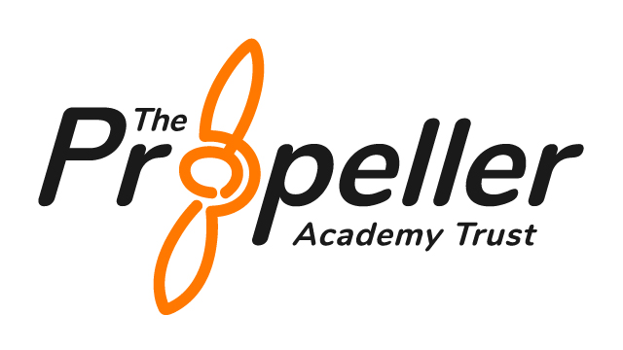
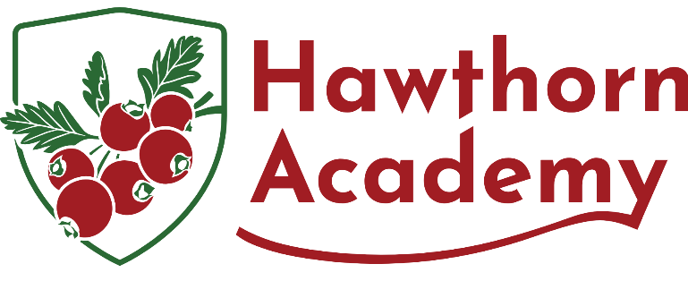

Anti-bully Policy
Trauma-Informed

Statutory Policy | Yes
Frequency of Review | See DfE guidance
Author | Headteacher
Approved by | Local Governing Board
Date Approved
Reviewed | Month Year
Date of Next Review | Month Year (unless there is a statutory or material change)

Policy Scope and Purpose
This Anti-Bullying Policy applies to all members of the Hawthorn Academy community, including pupils, staff, volunteers, and visitors. It covers all behaviours and interactions occurring on the school premises, during off-site activities (e.g., school trips), and online (e.g., social media, messaging platforms). The purpose of this policy is to set clear expectations, promote a culture of safety and inclusion, and ensure swift, consistent responses to all forms of bullying. It aims to create an environment where every pupil feels safe, respected, and empowered to speak up.

Introduction
At Hawthorn Academy, we are committed to fostering a safe, nurturing, and inclusive environment for every child. This Anti-Bullying Policy is rooted in our whole-school, trauma-informed approach to behaviour, which emphasises safety, trust, and emotional wellbeing. Bullying of any form contradicts our core values of Belonging, Community, Respect, Aspiration, and Courage, and will not be tolerated under any circumstances.
We recognise that behaviour is a form of communication and that children who display bullying behaviours often have underlying unmet needs or past trauma. As such, our response to bullying is compassionate, personalised, and focused on both accountability and support. This policy complements our Behaviour and Relationships Policy, and should be read in conjunction with our Safeguarding and Anti-Cyberbullying policies.
We promote consistent, relational responses that empower pupils to reflect, repair, and grow in a community that values empathy, emotional regulation, and restorative practice.

Pupil Involvement
Pupils at Hawthorn Academy play an active role in shaping our anti-bullying approach. Through School Council meetings, Anti-Bullying Ambassador programmes, and termly pupil voice surveys, students contribute feedback, identify concerns, and help design initiatives to promote inclusion and respect. Their insights inform updates to this policy and the design of preventative strategies.

Support for Pupils with SEND
Pupils with Special Educational Needs and Disabilities (SEND), particularly those with communication difficulties, social processing needs, or SEMH profiles, are more vulnerable to bullying. Staff are trained to recognise and respond to the unique needs of these pupils with sensitivity and care. All support strategies are personalised, accessible, and co-produced where possible with pupils and families.

Staff Training and Responsibilities
All staff receive annual training on identifying, preventing, and responding to bullying, including specific modules on trauma-informed responses and digital harms. New staff are inducted into the behaviour and anti-bullying framework. Staff are responsible for reporting incidents promptly, using CPOMS, and contributing to restorative responses.

Communication with Parents and Carers
Parents and carers are partners in promoting pupil wellbeing. They are informed of any bullying incidents involving their child and are included in planning support and restorative actions. Workshops, newsletters, and meetings are used to keep families informed and involved in our anti-bullying culture.

What is Bullying?
Bullying is defined as repeated, intentional behaviour that causes physical or emotional harm, involving an imbalance of power. It can be verbal, physical, psychological, social, or cyber-based, and may be direct or indirect. Bullying can target individuals or groups based on perceived differences such as race, religion, gender, disability, sexual orientation, or social identity.
At Hawthorn Academy, we take a preventative, proactive, and restorative approach to bullying. We view bullying as a serious breach of our community values and recognise the need to support both those who are harmed and those who cause harm.

Types of Bullying
- Verbal: Name-calling, sarcasm, teasing, spreading rumours.
- Physical: Pushing, hitting, kicking, damaging property.
- Social/Emotional: Exclusion, humiliation, manipulation.
- Cyber: Online threats, harassment, and social media abuse.
- Prejudice-Based: Bullying related to protected characteristics (e.g. race, religion, SEN, disability, gender, sexuality).
- Sexual and Homophobic: Unwanted contact, sexualised name-calling, gender-based targeting.
- Peer-on-peer abuse: Including coercion, harassment, and harmful behaviour between pupils.

Preventing Bullying
Bullying is addressed through our curriculum (e.g. Here, Now, Next), assemblies, PSHE sessions, peer mentoring, and enrichment activities. We proactively promote empathy, difference, digital safety, and inclusion. All staff receive regular training in trauma-informed practice and how to identify and address all forms of bullying behaviour effectively.

Procedures and Support Pathways
All bullying concerns should be reported immediately to a trusted adult. Staff will listen empathetically, gather accounts from all involved, and ensure incidents are recorded on CPOMS and monitored. A trauma-informed, graduated response will be activated based on the severity and nature of the incident.
- Tier 1 (Initial concern): Verbal check-in, restorative conversation, mediation.
- Tier 2 (Persistent concerns): Individual Behaviour Support Plan review, family engagement, targeted emotional support.
- Tier 3 (Significant harm): Safeguarding referral, multi-agency planning, individualised behaviour support.

Support for Pupils
We provide wraparound support for all pupils involved in bullying incidents. Victims are offered safe spaces, trusted adult support, and therapeutic interventions. Pupils who display bullying behaviour are guided through restorative work, emotional coaching, and structured opportunities to repair relationships.

Roles and Responsibilities
All members of our community share responsibility for tackling bullying. Pupils are encouraged to speak out and support one another. Staff are expected to model respectful behaviour, respond with consistency and compassion, and follow safeguarding protocols. Families are invited to work with us in supporting their child’s emotional and social development.

Restorative and Relational Practice
Hawthorn Academy embeds restorative practices to address conflict and repair harm. These strategies align with our trauma-informed principles and the DfE’s emphasis on social, emotional, and mental health development (‘Mental Health and Behaviour in Schools’, DfE, 2018).
Key restorative practices include:
- Restorative conversations: Guided dialogue using scripted questions to explore harm and repair.
- Restorative circles: Facilitated peer-led spaces to build understanding and community.
- Behaviour repair plans: Agreed next steps developed with pupils, parents, and staff.
- Reparation activities: Creative or relational actions that contribute positively to the community.
- Use of restorative language in classrooms and around the school.

Empowering Bystanders and Peer Support
Bystanders have the power to prevent and stop bullying. According to research by the Anti-Bullying Alliance, peer intervention can stop bullying within 10 seconds in 57% of cases. At Hawthorn Academy, pupils are actively supported to become upstanders, not bystanders.
We achieve this by:
- Delivering workshops on how to intervene safely.
- Training Anti-Bullying Ambassadors through The Diana Award programme (https://www.antibullyingpro.com).
- Promoting the ‘Tell, Don’t Tolerate’ message through visual displays and digital media.
- Incorporating bystander roles into PSHE and drama sessions.
- Creating peer support roles and buddy systems, particularly for vulnerable pupils.

Cyberbullying and Online Safety
Cyberbullying is covered in our Anti-Cyberbullying and Safeguarding policies, and is treated as a serious form of abuse. The policy aligns with ‘Keeping Children Safe in Education’ (KCSIE 2024), which highlights the importance of addressing online safety.
Our provision includes:
- Online safety curriculum embedded in computing and PSHE (based on Education for a Connected World: https://www.gov.uk/government/publications/education-for-a-connected-world).
- Annual Safer Internet Day participation.
- Digital citizenship guidance and pupil charters.
- CPD for staff on recognising and responding to digital harms.
- Parental engagement via workshops, newsletters, and website updates.
- Clear mobile phone usage policy and social media guidance.
- Safe ICT filtering and monitoring in line with the DfE’s filtering and monitoring standards (https://www.gov.uk/guidance/meeting-digital-and-technology-standards-in-schools-and-colleges).

Monitoring, Recording, and Reporting
In accordance with DfE guidance (‘Preventing and tackling bullying’, DfE, July 2017), all incidents of bullying must be systematically logged, reviewed, and followed up. At Hawthorn Academy, staff record incidents promptly on CPOMS, including full details of the pupils involved, type of bullying, time, location, staff response, and outcomes.
Key monitoring strategies include:
- Weekly reviews by the safeguarding and behaviour teams.
- Analysis of trends to identify persistent hotspots, vulnerable groups, or repeat patterns.
- Half-termly summary reporting to the Trust.
- Governor monitoring through anonymised behaviour data.
- Pupil and parent surveys to evaluate perceptions of safety and effectiveness of anti-bullying work.

Success Criteria and Impact Review
The effectiveness of this policy is measured through reductions in bullying incidents, improved pupil perceptions of safety (measured through surveys), and positive trends in behaviour and wellbeing data. Senior Leaders review CPOMS logs weekly, conduct termly thematic reviews, and report outcomes to Governors. Action plans are updated to reflect emerging patterns.

Related Policies and Documents
- Behaviour and Relationships Policy
- Safeguarding and Child Protection Policy
- Anti-Cyberbullying Policy
- Acceptable Use of ICT Policy
- SEND Policy
- Complaints Policy
- Online Safety Policy

Policy Review and Development
This policy is reviewed annually and as needed in response to:
- Changes in national guidance (DfE, Ofsted, KCSIE, Equality Act).
- Safeguarding concerns or behaviour trends.
- Outcomes of parent and pupil surveys.
- Feedback from Anti-Bullying Ambassadors and School Council.
- Recommendations from governors and external professionals.
All updates are shared with staff and published on the school website.
Links to statutory guidance:
- Preventing and Tackling Bullying: https://www.gov.uk/government/publications/preventing-and-tackling-bullying
- KCSIE 2024: https://www.gov.uk/government/publications/keeping-children-safe-in-education--2
- Equality Act 2010: https://www.legislation.gov.uk/ukpga/2010/15/contents
- Behaviour in Schools Guidance (2024): https://www.gov.uk/government/publications/behaviour-in-schools

