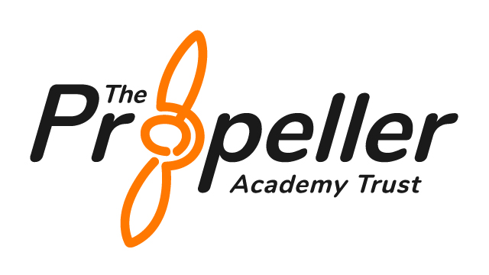


EAL Policy
(English as an Additional Language)

Statutory Policy | No
Frequency of Review | Every 2 years
Author | Headteacher
Approved by | Local Governing Board
Date Approved
Reviewed | June 2025
Date of Next Review | Jule 2027 (unless there is a statutory or material change)

The government definition of a bilingual learner is that it refers to 'all pupils who use or have access to more than one language at home or at school – it does not necessarily imply full fluency in both or all languages' (DfES 2003). Diversity of EAL learners.

Hawthorn Academy is a specialist SEMH setting where the emotional wellbeing, identity, and voice of every pupil is central. This includes pupils with English as an Additional Language, who may also face social, cultural, or linguistic barriers that impact access to learning. This policy recognises that EAL pupils may also have SEMH needs and that a trauma-informed, relational approach underpins our support.

Aims
Hawthorn Academy aims to ensure that all EAL pupils are able:

- To use English confidently and competently.
- To use English as a means of learning across the curriculum
- To ensure that EAL pupils are fully included into the life and work of Hawthorn.
- To ensure that pupils whose first language is not English reach their full potential.

Objectives
- To identify and assess individual pupils’ needs as soon as possible.
- To acknowledge the importance of pupils’ home language and to build upon their existing skills and knowledge.
- To make use of their knowledge of other languages.
- To ensure parent/carers and pupils are involved in the process.
- To promote a whole school responsibility towards EAL pupils.
- To ensure that appropriate and realistic levels of attainment are decided upon within each curriculum area.
- To make appropriate use of external agencies.

Management and Administration
- Whole School Approach
English as an alternative language is addressed in all department by form tutors and subject teachers.

Pupils with little English will receive additional tuition. In-class support will be provided if finances allow.
Pupils are encouraged to sit an external examination in their first language to build their confidence to achieve.

Documentation
All documentation and records are maintained by the Headteacher/SENDCO and are confidential to the parent/carers and to those members of staff associated with the child concerned.

Partnership with Parent/carers
We aim to work closely with parents/carers of EAL pupils and ensure that they are encouraged to become involved in school activities.

Parent/carers will be informed of their child’s progress regularly and will be invited into school to discuss any concerns.

Translators will be made available for parents/carers with EAL, upon request, for meetings such as EHCP reviews.

Procedure
Information will be gathered about:
- The pupil’s linguistic background and competence in other languages.
- The pupil’s previous educational and schooling activities and where appropriate the family’s biographical background.
- The pupil’s level of English using the EAL scales.
- Where appropriate, the pupil’s views will be gathered to ensure their experience, preferences, and aspirations are reflected in the support plan.

Strategies to ensure access to the Curriculum
  - Referral to external agencies, if necessary.
  - Initial direct teaching to aid acquisition of English.
  - Use of bi-lingual resources, e.g., dictionaries, on-line support, Key Word lists.
  - Collaborative group work and peer support.
  - Enhanced opportunities for speaking and listening.
  - In-class support (if funding available).
  - Additional visual support, e.g., posters, non-verbal clues.
  - The use of writing frames.
  - Regular feedback from staff.
  - Access for teaching staff to ICT support materials.
  - Access to emotional wellbeing support, including trauma-informed mentoring or key adult support, where appropriate.

Monitoring
- Pupil’s acquisition of English to be monitored using EAL scales.
- Pupil’s attainment in curriculum areas to be monitored using:
- Termly IEPs (Pupils Individual Educational Plans).
- Discussion with subject staff.
- Annual School Report.

Funding
We receive no funding at present from the Local Authority.

Resources
A range of resources are used to support a pupil’s linguistic development. These include games, differentiated work sheets, keyword lists, bi-lingual dictionaries and computer software.

